### Practical File

### Of

### Problem Solving using Python Programming

### 24CSE0101

#### Submitted

#### in partial fulfillment for the award of the degree of

## BACHELEOR OF ENGINEERING

***in***

COMPUTER SCIENCE & ENGINEERING



**CHITKARA UNIVERSITY**

**CHANDIGARH-PATIALA NATIONAL HIGHWAY**

**RAJPURA (PATIALA) PUNJAB-140401 (INDIA)**

##### December, 2024

##### **Submitted To: Submitted By:**

##### Dr. Sanjoy Kumar Debnath Krishna Sharma

##### Python Teacher 2410991209

##### Chitkara University, Punjab 1st Sem (2024-28)

##### **Practical File**

##### **(a) Write a** [**Python Program to Calculate the Area of a Triangle**](https://www.programiz.com/python-programming/examples/area-triangle)**.**

##### **Ans.**

##### **Aim**: To calculate area of a triangle

##### **Formula Used**: A=1/2×base×height

##### **Code**:

##### 

**Sample Input: Sample Output**

Base=10 Area=100

Height=20

**Result/Output:-**



**(b)** **Write a** [**Python Program to Swap Two Variables**](https://www.programiz.com/python-programming/examples/swap-variables)**.**

##### **Ans.**

##### **Aim**: To Swap values of two Variables

##### **Code**:

##### 

**Sample Input: Sample Output**

Value of A=2 Value of A=5

Value of B=5 Value of B=2

**Result/Output:-**

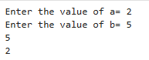

**(c) Write a** [**Python Program to Convert Celsius to Fahrenheit**](https://www.programiz.com/python-programming/examples/celsius-fahrenheit)**.**

**Ans.**

##### **Aim**: To Convert Celsius to Fahrenheit

##### **Formula Used**: (Celsius*9/5)+32

**Code**:



**Sample Input: Sample Output**

Temp in Celsius: 2 Temp in Fahrenheit: 75.2

**Result/Output:-**



**2. (a) Write a** [**Python Program to Check if a Number is Odd or Even**](https://www.programiz.com/python-programming/examples/odd-even)

##### **Ans.**

##### **Aim**: To Check if a Number is Odd or Even

**Code:**

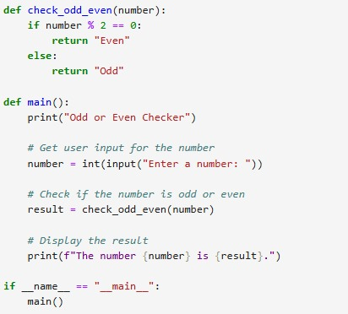

**Sample Input: Sample Output**

25 Odd

**Result/Output:-**



**(b) Write a** [**Python Program to Check if a Number is Positive, Negative or 0**](https://www.programiz.com/python-programming/examples/positive-negative-zero)

##### **Ans.**

##### **Aim**: To Check if a Number is Positive, Negative or 0

**Code:**

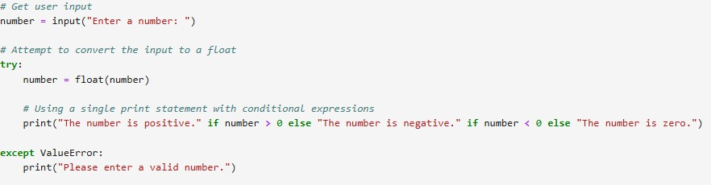

**Sample Input: Sample Output**

-24 Negative

**Result/Output:-**



**(c) Write a** [**Python Program to Check Armstrong Number**](https://www.programiz.com/python-programming/examples/armstrong-number)

##### **Ans.**

##### **Aim**: To Check Armstrong Number

**Code:**

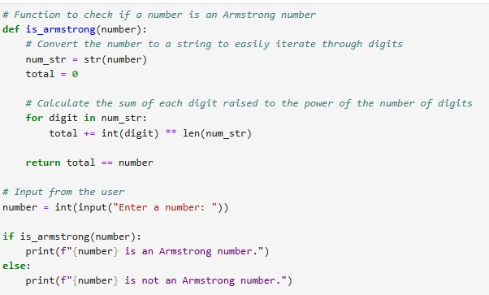

**Sample Input: Sample Output**

20 Not a Armstrong no.

**Result/Output:-**



1. **(a) Write a Python program to check if a given number is Fibonacci number.**

##### **Ans.**

##### **Aim**: To Check if a given number is Fibonacci number

**Code:**

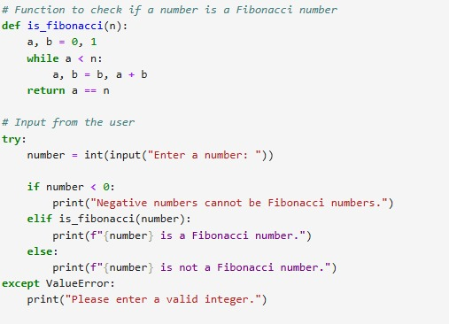

**Sample Input: Sample Output**

9 Not a Fibonacci no.

**Result/Output:-**



**(b) Write a Python program to print cube sum of first n natural numbers.**

##### **Ans.**

##### **Aim**: To print cube sum of first n natural numbers.

**Code:**

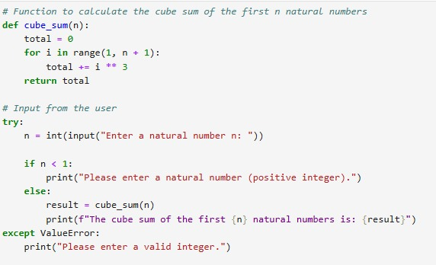

**Sample Input: Sample Output**

1-10 3025

**Result/Output:-**



**c.) Write a Python program to print all odd numbers in a range.**

##### **Ans.**

##### **Aim**: To print all odd numbers in a range.

**Code:** 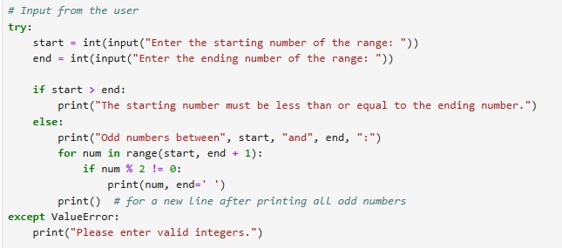

**Sample Input: Sample Output**

1-25 1 3 5 7 9 11 13 15 17 19 21 23 25

**Result/Output:-**

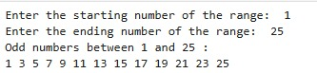

1. **(a) Write a Python Program to Print Pascal Triangle.**

**Ans.**

##### **Aim**: To print Pascal Triangle

##### **Code:**

##### 

**Sample input Sample output**

No of rows =**5**  **1**

**1 1**

**1 2 1**

**1 3 3 1**

**1 4 6 4 1**

**Result/Output:-**

##### 

**(b) WAP to Draw the following Pattern for n number:**

**Ans.**

##### **Aim**: To draw the pattern for n number

**Code:**

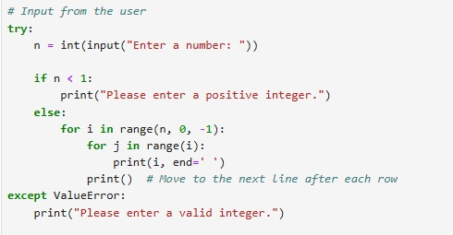

**Sample Input: Sample Output**

9 9 9 9 9 9 9 9 9 9

8 8 8 8 8 8 8 8

7 7 7 7 7 7 7

6 6 6 6 6 6

5 5 5 5 5

4 4 4 4

3 3 3

2 2

1

**Result/Output:-**

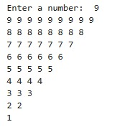

1. **Write a program with a function that accepts a string from keyboard and create a new string after converting character of each word capitalized.**

**Ans.**

##### **Aim**: To accepts a string from keyboard and create a new string after converting character of each word capitalized.

##### **Code:**

##### 

**Sample Input:** hii...i am emily a cse student at chitkara university, rajpura

**Sample Output:** Hii...i Am Emily A Cse Student At Chitkara University, Rajpura

**Result/Output:-**



1. **(a) Write a program that accepts a list from user. Your program should reverse the content of list and display it. Do not use reverse () method.**

**Ans.**

**Aim**: To Write a program that accepts a list from user

##### **Code:**

##### 

**Sample Input:** Mathematics Hindi English Science

**Sample Output: [‘**Mathematics Hindi English Science’]

**Result/Output:-**



**(b)** **Find and display the largest number of a list without using built-in function Max ().**

**Your program should ask the user to input values in list from keyboard.**

**Ans.**

**Aim**: To display the largest number of a list without using built-in function Max ().

##### **Code:**

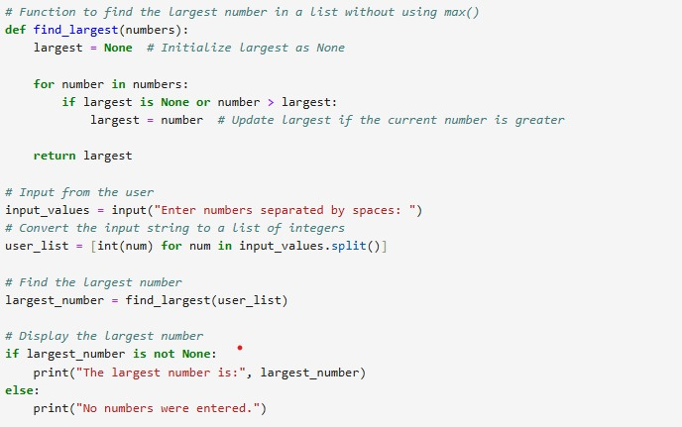

**Sample Input:**   **Sample Output:**

2 4 8 10 Largest Number: 10

**Result/Output:-**

‘



1. **Find the sum of each row of matrix of size m x n.**

**Ans.**

**Aim**: sum of each row of matrix of size m x n.

**Code:**

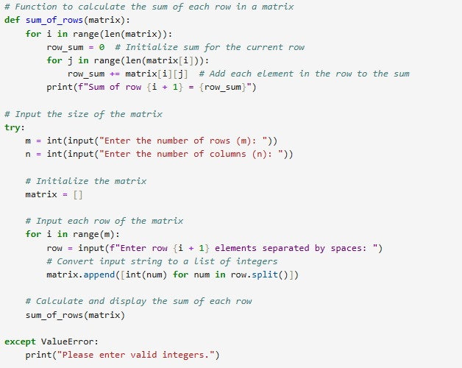

**Sample Input:**   **Sample Output:**

m=3, n=3 Sum of R1: 6

R1 elements: 1 2 3 Sum of R2: 15

R2 elements: 4 5 6 Sum of R3: 24

R3 elements: 7 8 9

**Result/Output:-**

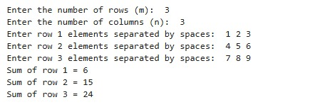

**8. (a) Write a program that reads a string from keyboard and display:**

* The number of uppercase letters in the string.

* The number of lowercase letters in the string.

* The number of digits in the string.

* The number of whitespace characters in the string.

**Ans.**

**Aim:** A program that reads a string from keyboard and display uppercase letters, lowercase letters,

number of digits, number of whitespace characters in a string.

**Code:**

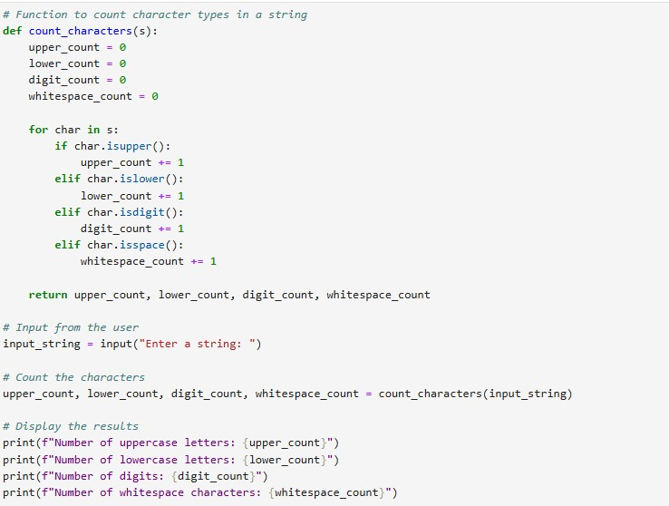

**Sample Input:**  **Sample Output:**

Any string:  **@ChitkaraUniversity11** Number of Uppercase letters: **2**

Number of Uppercase letters: **16**

Number of Uppercase letters: **2**

Number of Uppercase letters: **2**

**Result/Output:-**

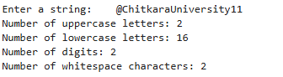

**(b)** [**Python Program to Find Common Characters in Two Strings**](https://www.sanfoundry.com/python-program-check-common-letters-string/)**.**

**Ans.**

**Aim:** To Find Common Characters in Two Strings

**Code:**

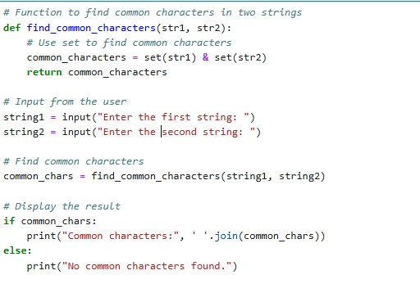

**Sample Input:**  **Sample Output:**

First string: **Chitkara** Common Characters: **‘i r t’**

Second String: **University**

**Result/Output:-**



**c)** [**Python Program to Count the Number of Vowels in a String**](https://www.sanfoundry.com/python-program-count-number-vowels-string/)**.**

**Ans.**

**Aim:** To Find Common Characters in Two Strings

**Code:**

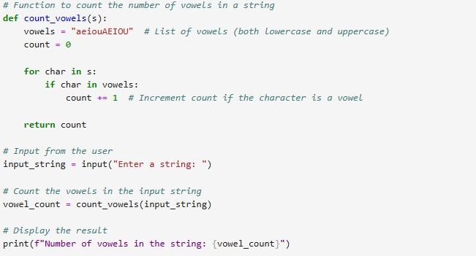

**Sample Input:**  **Sample Output:**

Enter a string: **Chitkara** **University** Number of vowels: **7**

**Result/Output:-**



**9.**  (**a) Write a Python program to check if a specified element presents in a tuple of**

**tuples.Original list: ((‘Red’ ,’White’ , ‘Blue’),(‘Green’, ’Pink’ , ‘Purple’), (‘Orange’, ‘Yellow’, ‘Lime’))**

**Ans.**

**Aim:** To check if a specified element presents in a tuple of tuples.

**Code:**

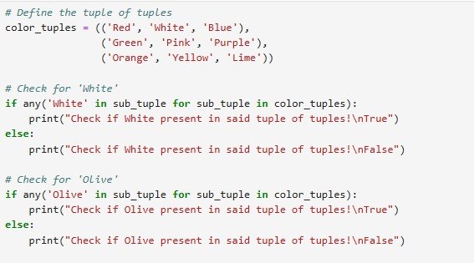

**Sample Input:**  **Sample Output:**

To check if white present in tuple:  **True**

To check if olive present in tuple: **False**

**Result/Output:-**

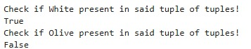

**(b) Write a Python program to remove an empty tuple(s) from a list of tuples.**

**Ans.**

**Aim:** To remove an empty tuple(s) from a list of tuples.

**Code:**

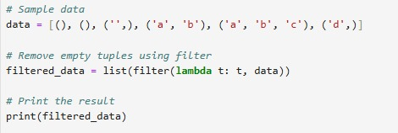

**Sample Input:**  **Sample Output:**

[(), (), ('',), ('a', 'b'), ('a', 'b', 'c'), ('d')][('',), ('a', 'b'), ('a', 'b', 'c'), 'd']

**Result/Output:-**



**10. Write a Program in Python to Find the Differences Between Two Lists Using Sets.**

**Ans.**

**Aim:** To Find the Differences Between Two Lists Using Sets.

**Code:**

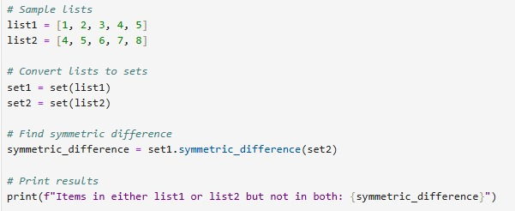

**Sample Input:**  **Sample Output:**

L1: **[1, 2, 3, 4, 5] {1, 2, 3, 6, 7, 8}**

L2:[**4, 5, 6, 7, 8**]

**Result/Output:-**



**11. (a) Write a Python program Remove duplicate values across.**

**Ans.**

**Aim:** To Remove duplicate values across.

**Code:**

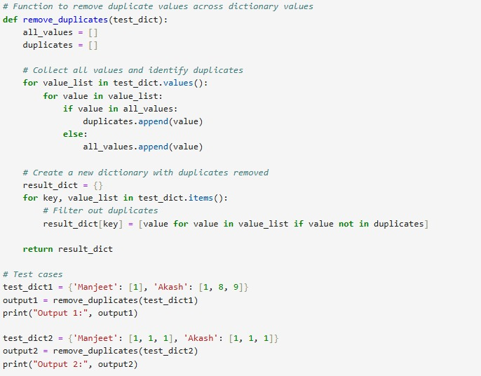

**Sample Input:**  **Sample Output:**

{‘Manjeet’: [1], ‘Akash’: [1, 8, 9]} {‘Manjeet’: [], ‘Akash’: [8, 9]}

{‘Manjeet’: [1, 1, 1], ‘Akash’: [1, 1,1]} {‘Manjeet’: [], ‘Akash’: []}

**Result/Output:-**



**(b) Write a Python program to Count the frequencies in a list using dictionary in Python.**

**Ans.**

**Aim:** To Count the frequencies in a list using dictionary in Python**.**.

**Code:**

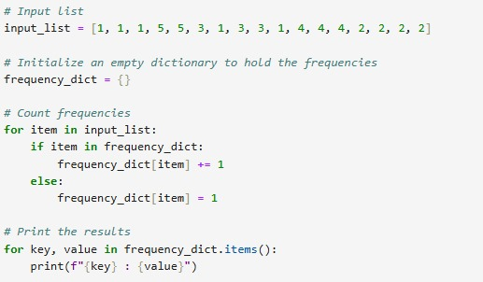

**Sample Input:**  **Sample Output:**

[1, 1, 1, 5, 5, 3, 1, 3, 3, 1,4, 4, 4, 2, 2, 2, 2] 1 : 5

5 : 2

3 : 3

4 : 3

2 : 4

**Result/Output:-**



**12. (a) Write a Python Program to Capitalize First Letter of Each Word in a File.**

**Ans.**

**Aim:** To Count the frequencies in a list using dictionary in Python**.**.

**Code:**

**Sample input Sample output**

hello world Hello World

**Result/output-**

**(b) Write a Python Program to Print the Contents of File in Reverse Order.**

**Ans.**

**Aim:** To Print the Contents of File in Reverse Order

**Code:**

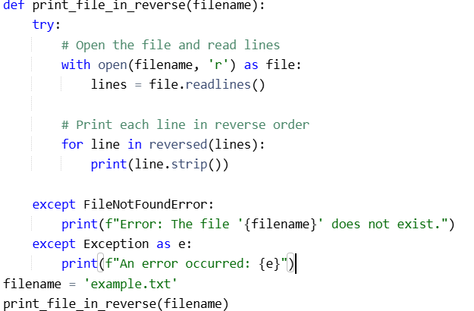

**Sample input Sample output**

**Hello, World! Each line will be printed in reverse order**

**This is a sample file. It has multiple lines.**

**It has multiple lines. This is a sample file.**

**Each line will be printed in reverse order. Hello, World!**

**Result/output**

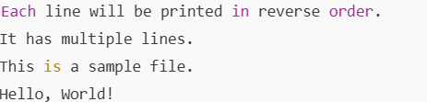

**13. Write A Program to catch an exception and handle it using try and except code blocks.**

**Ans.**

**Aim:** To catch an exception and handle it using try and except code blocks

**Code:**

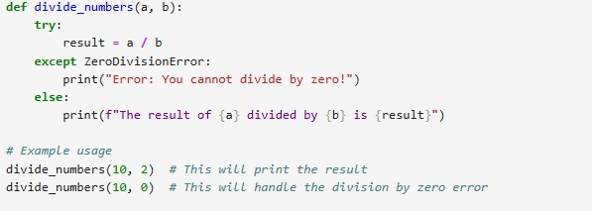

**Sample Input:**  **Sample Output:**

10/2=5 Error: You cant divide by zero

**Result/Output:-**



**14. Write a Python Program to Append, Delete and Display Elements of a List using Classes.**

**Ans.**

**Aim:** To Append, Delete and Display Elements of a List using Classes

**Code:**

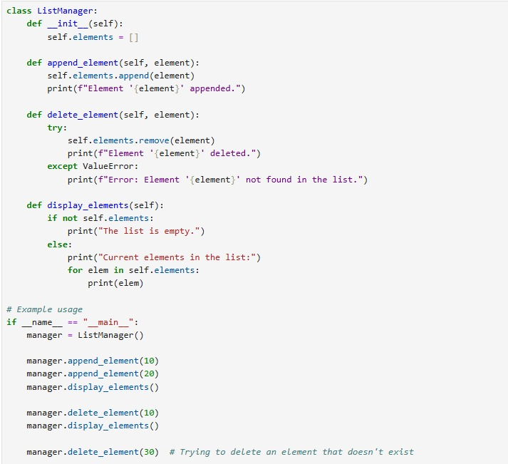

**Sample Input:**  **Sample Output:**

Elements: 10,20 Error: element 30 not found

**Result/Output:-**

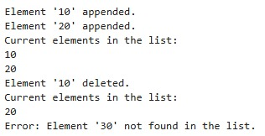

**15. Write a** [**Python Program to Find the Area and Perimeter of the Circle using Class**](https://www.sanfoundry.com/python-program-class-compute-area-perimeter-circle/)**.**

**Ans.**

**Aim:** To Append, Delete and Display Elements of a List using Classes

**Code:**

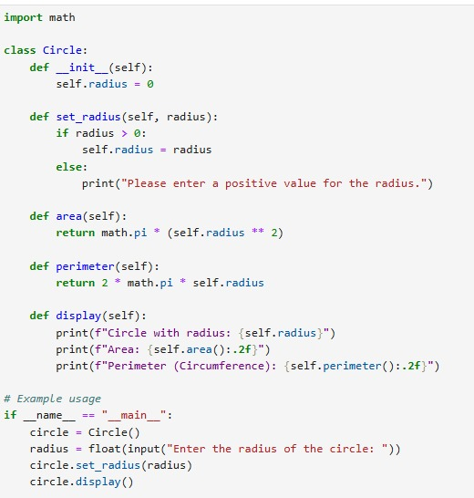

**Sample Input:**  **Sample Output:**

Radius of circle: 3 Area= 28.27

Perimeter: 18.85

**Result/Output:-**

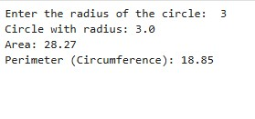

**16. Create an interactive application using Python's Tkinter library for graphics programming.**

**Ans.**

**Aim:** To Append, Delete and Display Elements of a List using Classes

**Code:**

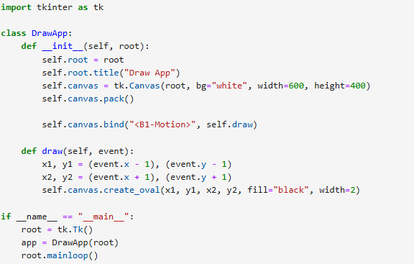

**Sample Input:**  **Sample Output:**

**Result/Output:-**